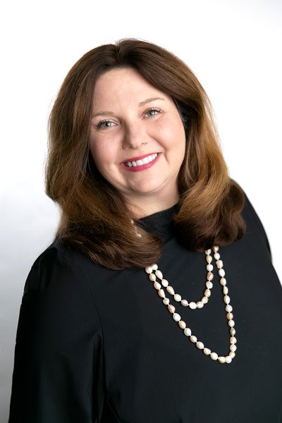

January 2022: An Anniversary of Coming Together “One Team. One Dream.”
Spotlight on Rhonda Bradley, CEO of ImageWorks Commercial Interiors

Aside from the start of a fresh New Year, why is January special to you?

I love beginnings, planning, goal setting and the anticipation of what is ahead. ImageWorks has been blessed with growth and fortunate to have had the opportunity to expand our reach. This January is special because it is the second anniversary of our teams coming together with the acquisition of Todays Office locations in Little Rock and NWA and Leitz in Panama City, Florida. Our existing Little Rock and Memphis locations are richer because of the experienced professionals we have added to our team.

What are you most looking forward to in 2022?

I have never been more excited about where we are in terms of continuing to be a great partner to all our customer audiences and the communities we serve. Aside from our growing geography, 2022 marks the beginning of the first full year with our newly established leadership team. Key roles in operations, marketing, technology, human resources, and finance are now directed by some of the most remarkable and talented individuals in our industry and are critical to our future success. Because of them, I can focus on being the visionary of our organization, imagining and exploring the next “big thing” that will excite and inspire our customers and key influencers.

Tell us about the brand alignment you are launching.

In the next few weeks, we will be moving toward one aligned brand under the ImageWorks logo. We will be synthesizing the rich history of MBI, Today’s Office, and Leitz onto one platform. One company, multiple locations, offering a comprehensive product and service portfolio enterprise wide. Some examples of our integrated interiors approach include architectural products, ancillary collections, expert incorporation of technology within the workplace, and commercial moving services. We are investing in technology in a powerful way to enhance each client’s experiences. Everything we do is about attention to detail in delivering our best to those that have put their trust in us. Sharing our resources, experience, and knowledge across all locations will create great synergy and increase the overall value we bring to our audiences. We are back in the office and anticipate growing our presence in each of our markets by continuing to build strong connections in 2022.

